
Year 8

Term 3 Test

Resources allowed: A handwritten A4 notes page double sided

Name: ________________________ Class: ____ Total Time: 50 minutes Mark /50

- [3 marks]
Complete the following sentences by using the following words. Note: there are more words than gaps. Substitute, coefficient, highest common factor (HCF), constant, like terms.

a) To _____________ values means to replace each variable in an expression with a number to obtain a final value.

b) ____________ contain exactly the same variables with the same powers.

c) The _____________ of a set of terms is the largest factor that divides into each term.

- [1,1,1,2,2 = 7 marks]
Simplify the following

- [1,2,2 = 5 marks]
Expand the following expressions and simplify wherever possible
- b)

- [1,2,2= 5 marks]
Factorise each of the following algebraic expressions

- [2 marks]
Find the value of $2a- b^{2}$ when a = 3 and b = -2

- [1, 1, 1, 1 = 4 marks]
Convert the following 12-hour times to 24-hour time:
- 6:00am b) 3:24pm

- 10:20 pm d) 12:01 am

- [1, 1, 1 = 3 marks]

The stem-and-leaf diagram shows the number of sweets in each of 25 bags.
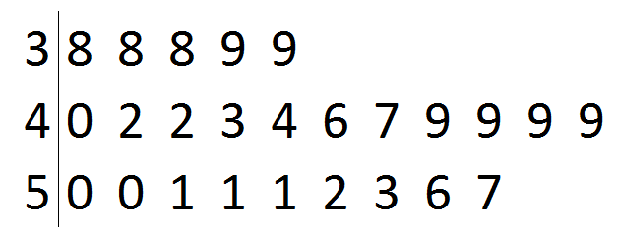
Key: 3|8 = 38 sweets

a) Calculate the range of the number of sweets in the bags.

b) Write down the mode of the number of sweets in the bags.

c) Determine the median number of sweets in the bags.

- [1, 1, 2 = 4 marks]
The following histogram gives the marks for a history quiz.
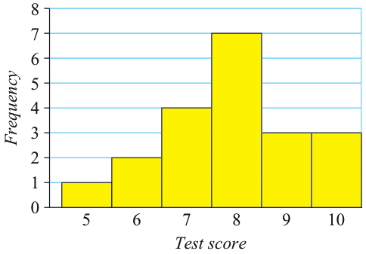
- What is the mode?

- How many students did the test?

- What was the mean score?

- [17 marks]
Solve the following for the variable. Show your working for each step for full marks.
j) $5e-3=2e+9$

